D E P A R T M E N T O F E N V I R O N M E N T A L Q U A L I T Y

HOW TO PROPERLY RECYCLE
APPLIANCES WITH FREON
2

WHAT IS FREON?
1
Commonly associated with chlorofluorocarbons (CFCs) and hydrochlorofluorocarbons (HCFCs), Freon compounds have a chemical

structure that enables them to shift between liquid and gas states efficiently, making them ideal for cooling systems in appliances such as fridges/freezers, AC units, and dehumidifiers.

IDENTIFY IF YOUR APPLIANCE HAS FREON
3
Check the date of manufacture -
from the 90s or before it likely contains Freon.
Google the model number and check the manufacturer’s website. Check the compressor for a code such as R-22/R-12 then Google.
If you are still unsure, ask a technician.
4

WHY IS FREON HARMFUL?
When CFCs, like Freon, are released into the air, they can break down and deplete the ozone layer, which is essential for warding off UV radiation.
Once it was discovered that CFCs like Freon were so environmentally damaging, the Montreal Protocol was agreed on, which saw CFCs phased out worldwide in the 90s.


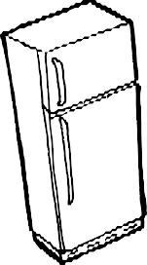
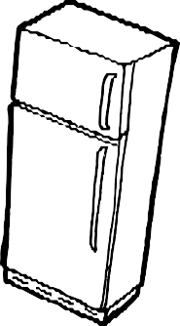


MY APPLIANCE HAS FREON, WHAT DO I DO?
Freon removal must be performed by a licensed expert, do not attempt removal yourself. Many solid waste facilities and local scrap metal recyclers accept appliances with Freon and preform the evacuations on-site for an additional charge. Additionally, you can check with your local HVAC company to perform the Freon evacuation.
5

RECYCLE YOUR APPLIANCES!
As previously mentioned, check with your local solid waste facility as well as your
local scrap metal recycler for appliance acceptance. Ensure that all policies are adhered to including disabling doors and removing Freon prior to disposal if stipulated. These facilities typically accept appliances for recycling. A small fee may be associated with acceptance.

Additional Resources:
- Earth911.com – Look up where you are able to recycle appliances.
- For more information, please contact Dusti Johnson (406-444-6499) or Megan Wingard (406-444-2835), DEQ’s Materials Management Specialists.

